**Engineering Electromagnetic– Experiment 3**

1. **Objectives:**
2. Get familiar with the spatial magnetic field that is produced by an electric current loop.
3. Calculate the magnetic field distribution and plot the relevant graphs through MATLAB.
4. **Related knowledge:**

Biot and Savart derived the expression of the magnetic field created by an elementary current, which is called as Biot–Savart law.

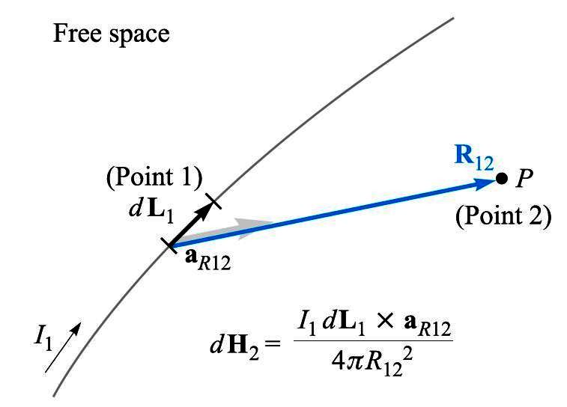

Figure 1: Magnetic field created by an elementary current

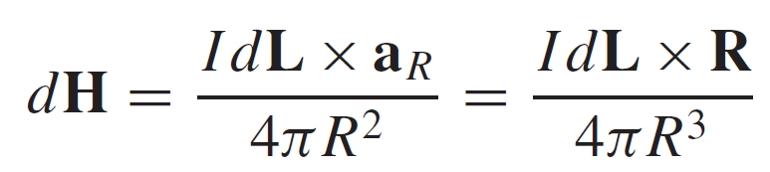 (1)

where **H** is magnetic field intensity vector, I*d***L** is elementary current vector, **R** is the vector that points from the elementary current I*d***L** to a field point *P* and its magnitude is *R.*

As for the magnetic field created by an electric current loop, we have used the Biot – Savart law to derive the distribution of the magnetic field intensity along the center axis of the current loop:

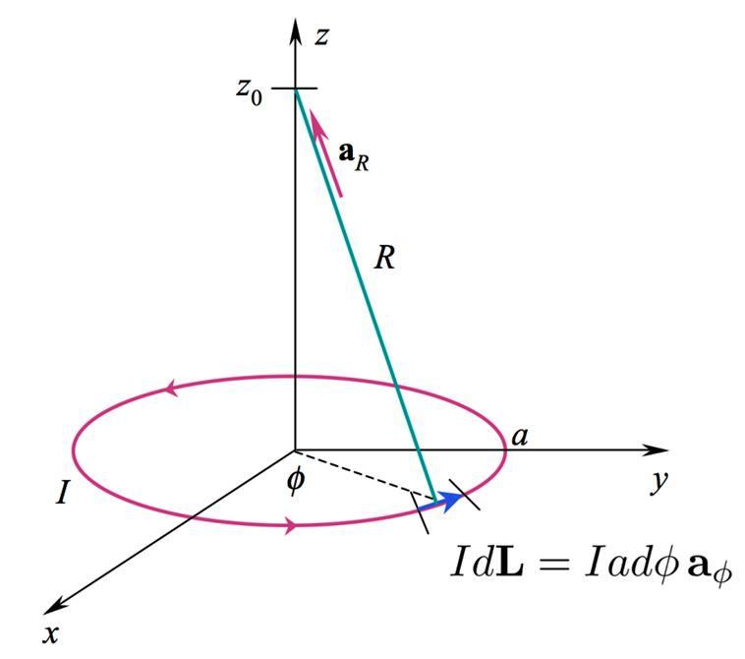

Figure 2: Magnetic field distribution along the center axis of a current loop

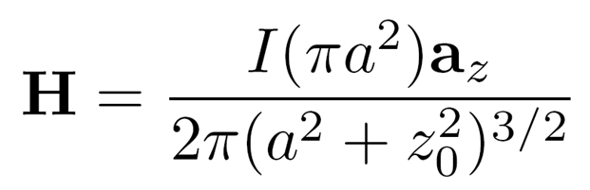 (2)

Where *a* is the radius of the current loop, *I* is the current in the current loop, z0 is the coordinate of the field point (located on the center axis, i.e. *z* axis). However, for the field points that are not on the center axis, it would be hard to deploy Biot – Savart law to derive an analytical solution for the magnetic field intensity.

Similarly, magnetic field also follows the superposition principle. Therefore, we can divide the current-carrying conductor into many elementary currents. Thus, the magnetic field created by the current-carrying conductor is equal to the superposition of the magnetic fields created by all elementary currents. Based on this, we can use MATLAB program to find the distribution of the magnetic field created by an electric current loop at any field point.

Likewise, as shown in figure 2, an electric current loop with radius *a* is located in the *xy* plane and its center is located at the origin *O*. The magnitude of the current in the loop is *I* and the direction of the current is shown as the arrow in figure 2. For simplicity, we will only analyze the *yz* plane distribution of the magnetic field created by the current loop. Here are the MATLAB code:

clear all

a=1; %Input the radius of the current loop

I=100; %Input the current value in the current loop

C=I/(4*pi); %Merge the constants

N=50; %Set the number of division

ym=3; %Set the range of y direction in the field domain

zm=3; %Set the range of z direction in the field domain

y=linspace(-ym,ym,20); % Equally divide y axis into 20 parts

z=linspace(-zm,zm,20); % Equally divide z axis into 20 parts

theta0=linspace(0,2*pi,N+1); %Division of the angle of circumference

theta1=theta0(1:N);

x1=a*cos(theta1); y1=a*sin(theta1); %The start point coordinate of each segment of the loop

theta2=theta0(2:N+1);

x2=a*cos(theta2); y2=a*sin(theta2); %The ending point coordinate of each segment of the loop

zc=0; xc=(x2+x1)./2; yc=(y2+y1)./2; %Calculate the 3 coordinate components of the midpoint of

%each segment of the loop.

dlz=0;dlx=x2-x1;dly=y2-y1; %Calculate the 3 length components of each segment

%vector dl.

NGx=20; NGy=20; %Grid dimension

Hy=zeros(20);Hz=zeros(20);H=zeros(20); %Construct the H matrix

for i=1:NGy %Loop computation of the value of H(x,y) in each grid

for j=1:NGx

rx=0-xc; ry=y(j)-yc; rz=z(i)-zc; %Calculate the 3 length components of the radius vector r,

% and r is in the z = 0 plane.

r3=sqrt(rx.^2+ry.^2+rz.^2).^3; %Calculate r cube

dlXr_y=dlz.*rx-dlx.*rz; %Calculate the y, z components of the cross product dl×r,

%x component is 0.

dlXr_z=dlx.*ry-dly.*rx;

Hy(i,j)=sum(C.*dlXr_y./r3); %Accumulate the magnetic field intensity created

%by each segment of the loop.

Hz(i,j)=sum(C.*dlXr_z./r3);

H=(Hy.^2+Hz.^2).^0.5; %Calculate the magnitude of H

end

end

subplot(1,3,1), quiver(y,z,Hy,Hz); %Plot the vector graph of the magnetic field intensity

hold on

axis([-3,3,-3,3]);

plot(1,0,'ro',-1,0,'bo'), %Standard coil section

xlabel('y'),ylabel('z'), %Label the axis

subplot(1,3,2), mesh(y,z,H); %Plot the graph of magnetic field intensity

axis([-3,3,-3,3,0,100])

xlabel('y'),ylabel('z'),zlabel('H');

theta=[0 50 60 70 80 90 100 110 120 130 180].*pi/180; %Set the radian value of the streamlines

ys=1.1*cos(theta); %Set the streamline starting circle’s y coordinate

zs=1.1*sin(theta); %Set the streamline starting circle’s z coordinate

subplot(1,3,3), streamline(y,z,Hy,Hz,ys,zs); %Outwardly plot the magnetic line of force from the starting %circle.

streamline(y,z,-Hy,-Hz,ys,zs); %Inwardly plot the magnetic line of force from the starting %circle.

xlabel('y'),ylabel('z');

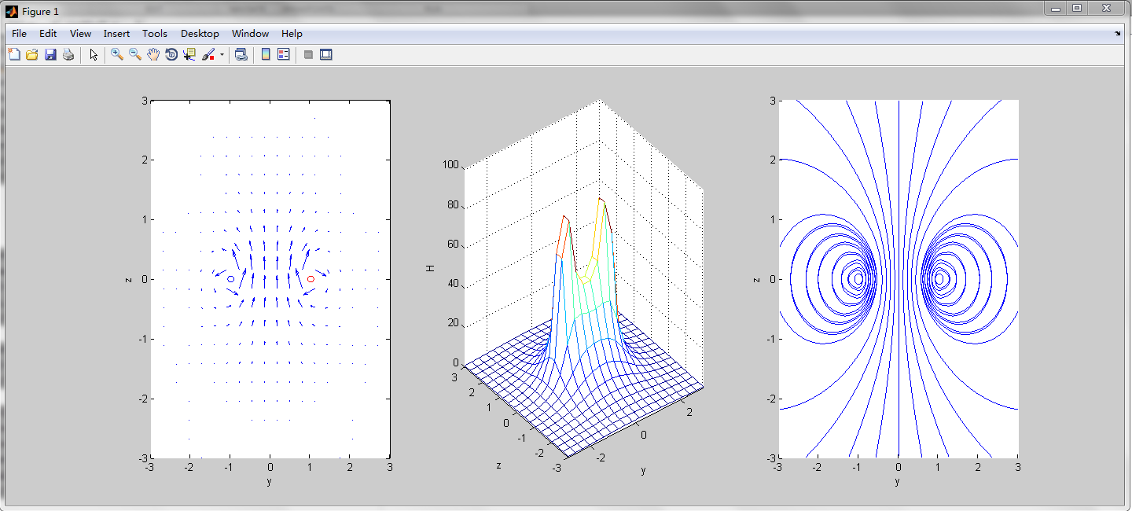

1. **Experiment content:**

Based on the analysis on the single current loop described above, use MATLAB to analyze the magnetic field distribution of the following two cases:

Case 1: Two current loops with the same radius *a* = 2m, and the current in both of the loops is 500A. Refer to figure 2, the two loops are parallel to the *xy* plane, and the loop centers are located at *O*1(0,0,-1), *O*2(0,0,1) respectively. The directions of the current are the same;

Note: For two parallelly placed current loops, when the distance between them is equal to their radius, this two-current-loops system is usually called Helmholtz coils. One characteristic of the Helmholtz coils is that the spatial magnetic field distribution between these two current loops is very uniform.

Experiment requirements: Calculate and plot the magnetic field intensity vector distribution (represented by arrows) and the magnetic field intensity magnitude distribution in the space between the two current loops (Helmholtz coils). For simplicity, you may only analyze the magnetic field distribution on the *yz* plane, especially for the magnetic field distribution at the region *y*=[-2,2], *z*=[-1,1]. The student name and student ID should be included in the generated figures’ titles.

Case 2: Set the current directions of the two loops in case 1 to be opposite. Analyze the magnetic field distribution on the *yz* plane again. The requirements are the same with case 1.

1. **Outline for the experiment report:**

**Engineering Electromagnetics – Experiment 3**

Name: **** Student ID: ****

1. Experiment task description
2. Case 1: MATLAB source code and experiment results (show the generated figures and briefly analyze the results).
3. Case 2: MATLAB source code and experiment results (show the generated figures and briefly analyze the results).
4. Inspiration (briefly state the discovery and findings from the experiment)